# Conflict Scenario

## **Review**

### Interpersonal Conflict Management Styles

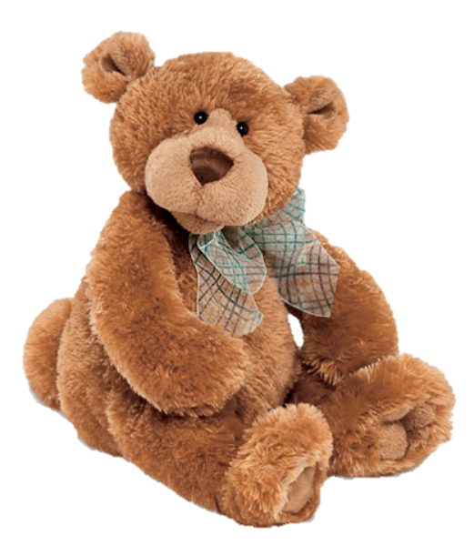

[CC 2.0 BY Matthew](https://www.flickr.com/photos/falcon1961/3304306800/)



[CC SA 3.0 Unported BY Jonathan Zander](https://en.wikipedia.org/wiki/File:Florida_Box_Turtle_Digon3.jpg)



[CC 3.0 BY Superawesomevectors](https://superawesomevectors.deviantart.com/art/Shark-Cartoon-Free-Vector-Illustration-643399222)



[CC0](https://pixabay.com/en/urban-lost-hiding-afraid-1002149/)

Low to High Concern for Other

Concern for Self



CC SA 2.0 Generic BY [Carine06 from UK](https://commons.wikimedia.org/wiki/File:Flickr_-_Carine06_-_%22I_give_up.%22.jpg)



CC 2.0 BY [Zabara Alexander](https://www.flickr.com/photos/zabara_tango/6955720271)



[CC0](https://commons.wikimedia.org/wiki/File:US_Army_53525_Soldiers_compete_in_Tae_Kwon_Do_tournament_for_Warrior_Country_level.jpg)

### **Interpersonal Conflict Resolution**

The following diagram shows a process that can be followed when trying to resolve interpersonal conflict.

### Listening

A considerable proportion of our communication involves listening, yet little attention is devoted to improving listening. HURIER is an acronym for tips that can be used to improve listening.

### “I” Phrases for Conflict Resolution

The “I” phrase is used during conflict resolutions to avoid attacking others. Open the conversation with a statement in first person, passive voice: “I feel … when … because … I would like …”

Adapted from (Dwyer 2012, p. 40)

## **Student Name and ID:** Declan Brennan 12196011

## **Student Name and ID:** Zachary Cannon 12195928

## **Scenario**

Find a partner. Read the scenario below. Choose one partner to be Joe Bloggs, and the other to be Jane Doe. Together, answer the following to help prepare you for the role play.

## **Scenario: Joe did not complete a task by the deadline**

Joe and Jane are working on a report that is due today. Joe was assigned the task of writing the executive summary. Unfortunately, Joe has not completed the task.

What is the most appropriate conflict management strategy for Jane to use in this situation? (Choose one)

Compete/Force

Compromise

Avoid/Withdraw

Collaborate/Confront

Accommodate/Smooth

Why did you choose the above conflict management strategy?

It’s going to be faster and more efficient than any other and turn out better than brute forcing it.

### **Listen and Understand**

How could Jane start the conversation?

Do you need some help with the executive summary?

Describe the purpose of the discussion. Describe the conflict. What questions could Jane ask to determine Joe’s perspective of the situation?

The purpose is to put Joe back on track. The conflict is that Joe did not finish his part of the report. She could ask questions such as Are you aware of the deadline?, Do you know what will happen if we don’t hand this in on time?.

Write sentences that features the “I” phrase, such as in the example below:

“I feel *[your feeling]* when *[their behaviour]* because *[effects on you]*. I would like *[alternative behaviour]*”.

Look mate, I’m a little angry at the moment. You haven’t done your job and it is going to affect me in a bad way. Because of you we both might fail this. So please get your ass on the computer and start typing.

Invent a reason why Joe did not complete the executive summary by the deadline.

Yeah, sorry about that Jane. I was out of state for the weekend dealing with something important.

How could Jane paraphrase Joe’s reason for missing the deadline to ensure that she understands Joe’s perspective?

Ok, so you weren’t here to do any of the work.

### **Empathise**

Now that Jane understands Joe’s perspective, how could Jane empathise with Joe? Write a response that shows that Jane identifies with Joe’s emotions.

I understand now that you didn’t mean to not do your work and I’m sorry for blowing my top.

### **Apologise**

Include an apology if it is appropriate.

Click or tap here to enter text.

### **Offer Solution**

What question could Jane ask to help build Joe’s involvement with potential solutions?

Are you going to be alright with this on your own? You can ask me for help if you need it. You only have a day to do this after all.

Come up with a way for Jane and Joe to settle on a solution.

After Joe asks for assistance they both work on the executive summary until it is complete.

### **Resolution**

How could Jane resolve the conflict? Jane needs to ensure that Joe agrees. Write a response that outlines appreciation for the solution.

Jane could offer her assistance in completing the summary and check if Joe is comfortable with this. After accepting joe and Jane work together to complete the task.

### **Reconciliation**

How could Joe reconcile the relationship and let Jane know that she is important to him?

Joe could apologize for not completing the summary again, and after that he can say that he didn’t mean to hurt Jane’s feelings and disrupt the working relationship between them.

How can Jane let Joe know she is listening while Joe is talking?

Summarize what Joe is saying and acknowledge what he is saying with nods and reactions.

What could Jane do if Joe started to withdraw from the conflict at any stage?

Try and get his attention again and reiterate how important this is.